 | Assignment No. 02 (Graded)  SEMESTER Spring 2023  CS403- Database Management System |  | Total Marks: 20  Due Date: 14-7-2023
MY YOUTUB CHANNEL LINK PLZ Subscribe
https://www.youtube.com/channel/UCtVDHPiy5J8F8y70efqSu3A

Instructions:
Please read the following instructions carefully before solving & submitting assignment:
It should be clear that your assignment will not get any credit (zero marks) if:
- The assignment is submitted after due date.
- The submitted assignment does NOT open or file is corrupted.
- The assignment is copied (from other student or ditto copy from handouts or internet).
- You are supposed to submit your assignment in .doc / Docx format. Any other formats like scan images, PDF, Zip, rar, bmp etc will not be accepted.
Objectives:
The objectives of this assignment are,

  - To give students the idea of the most commonly used RDBMS for designing physical database systems i.e., MS SQL SERVER.
  - To build and manage SQL Server databases.

  - To apply constraints e.g., Primary Key and foreign key on attributes.

  - To insert data in SQL tables, retrieve and manipulate data with SQL queries from tables.

Important Note: The assignment will be marked zero if the assignment solution does not have student own ID as database name. Copy all screenshots of SQL code and paste code screenshots in MS Word as your solution.
Note: Students can also use online SQL Editors to write and run the SQL commands for the given tasks.
For any query about the assignment, contact at cs403@vu.edu.pk
GOOD LUCK
 |  | Marks: 20
Question Statement:
Consider following ERD part from scenario of Assignment No. 1.
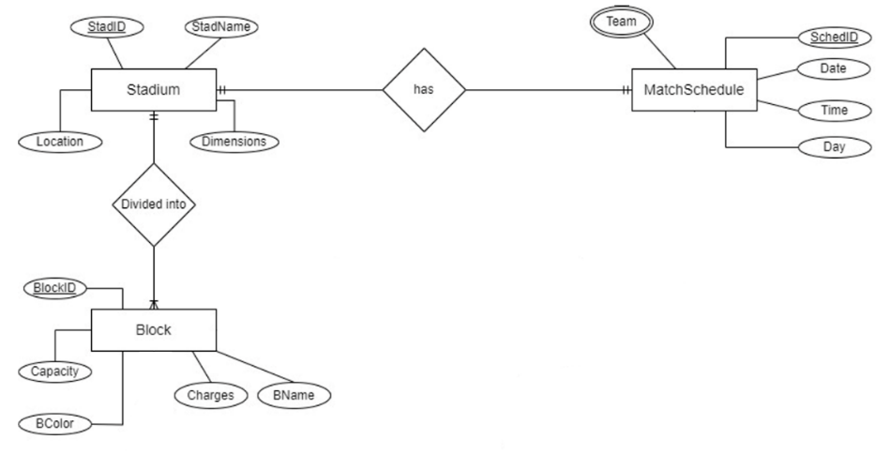
Tasks Description:
Task 1:
Write SQL statement to create a new database in SQL Server by your VU ID (sample screenshot is provided on the last page of this file).
Solution:
CREATE DATABASE MC123456;
Task 2:
Write SQL statements for the following:
- Create tables: Stadium, MatchSchedule and Block in database created in Task 1.

- For each table, you have to define all attributes/columns given in ERD with appropriate data types.
- You are also required to define Primary key of each table.
- Transform multi-valued attribute.
- Map all relationships and add foreign keys in appropriate tables according to relationships types.
Solution:
Stadium Table:

CREATE TABLE Stadium (
StadID INT PRIMARY KEY,
StadName VARCHAR(50),
Capacity INT
);
MatchSchedule Table:
CREATE TABLE MatchSchedule (
MatchID INT PRIMARY KEY,
StadID INT,
MatchDate DATE,
FOREIGN KEY (StadID) REFERENCES Stadium(StadID)
);

Block Table (with transformed multi-valued attribute):

CREATE TABLE Block (
BlockID INT PRIMARY KEY,
StadID INT,
BlockName VARCHAR(50),
Charges DECIMAL(10, 2),
FOREIGN KEY (StadID) REFERENCES Stadium(StadID)
);

Task 3:
Write SQL Statements to insert 2 records in each table.
Solution:
Inserting records into the Stadium table:
INSERT INTO Stadium (StadID, StadName, Capacity)
VALUES (1, 'Stadium A', 50000),
(2, 'Stadium B', 40000);

Inserting records into the MatchSchedule table:
INSERT INTO MatchSchedule (MatchID, StadID, MatchDate)
VALUES (1, 1, '2023-07-10'),
(2, 2, '2023-07-12');
Inserting records into the Block table:
INSERT INTO Block (BlockID, StadID, BlockName, Charges)
VALUES (1, 1, 'Block X', 50.00),
(2, 1, 'Block Y', 40.00),
(3, 2, 'Block Z', 45.00);

Task 4:
Write SQL Statements to:
- Display name and capacity of all blocks.
SELECT BlockName, Capacity
FROM Block
JOIN Stadium ON Block.StadID = Stadium.StadID;
- Display Average charges/amount of blocks using appropriate function.
SELECT AVG(Charges) AS AverageCharges
FROM Block;

- Remove column StadName from Stadium table.
ALTER TABLE Stadium
DROP COLUMN StadName;

Note: There should be one screenshot for each task i.e., 4 screenshots for 4 given tasks.
Sample Screenshot:
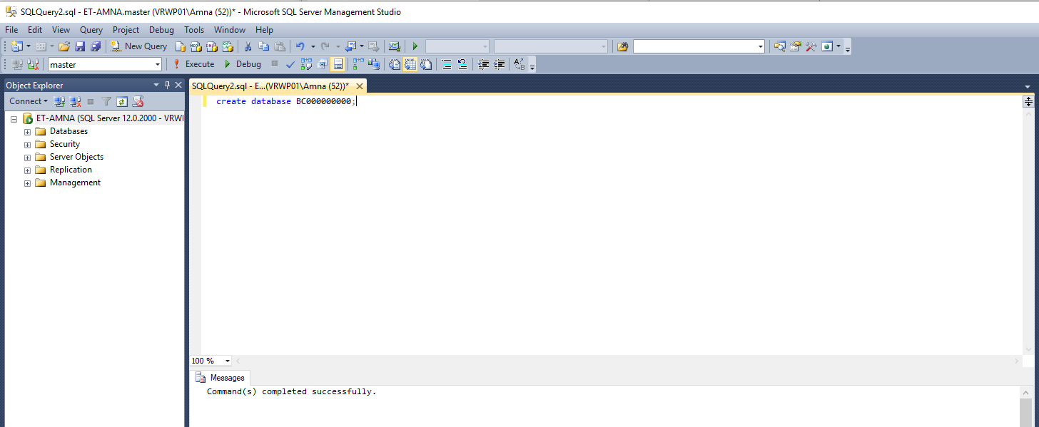

Note: Students can also use online SQL Editors to write and run the SQL commands for the given tasks.
Lectures Covered: This assignment covers Lecture # 24-30
Deadline: Your assignment must be uploaded/submitted at or before 14th July 2023.

